Chapter 5, Problem 79

Determine v_{o} in the op amp circuit of Fig. 5.102 using PSpice.

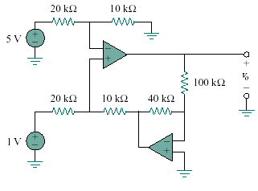
+
–

Figure 5.102
For Prob. 5.79.

